Website Creation (Sneaker Galaxy)
This is a multi-store website for a company called Sneaker Galaxy which sells all different brands of sneakers e.g puma, Jordan. This website is to enable the company to have an e-commerce site where customers can now acquire their favourite sneakers from the comfort of their own home.
- Website Specifications
- Website Objective
The objective of the website is to create an e-commerce platform that sells sneakers from multiple brands. The website aims to provide users with a convenient, fast and secure way to browse and purchase sneakers online.

- Goals of the website:
- To sell sneakers to a wide range of customers.
- To showcase popular brands such as Nike, Adidas and New Balance.
- To provide detailed product information (price, size, description).
- To ensure a smooth and user-friendly shopping experience.
- To make the website accessible on both mobile and desktop devices.

- Type of website/Content
The website will be an e-commerce website that combines:
- Commercial content (selling sneakers).
- Informational content (brand history, product details).

- Information Design & Taxonomy
- Information Architecture (structure)
The content of the website will include:
- Home Page
- Men’s sneakers
- Women’s sneakers
- Kid’s sneakers
- Brands
- About Us
- Contact Us
- Cart / Checkout

- Taxonomy (How content is organized)
Sneakers will be categorized based on:
- By Gender
- Men
- Women
- Kids

- By Brand
- Nike
- Adidas
- New Balance
- Jordan
- Puma

- By Size
- Kids: Size 1-13
- Adults: Size 1-10

- By Price
- Low Range
- Mid Range
- Premium

- Navigation (User Flow)
Example navigation path:
- Home → Category (Men/Women/Kids) → Select Product → Add to Cart → Checkout

- Technical Brief
- Software Used
The website will be developed using:
- HTML5 → Structure of the website.
- CSS3 → Styling and layout.
- Bootstrap → Responsive design.
- JavaScript → Interactivity (buttons, cart, validations.
- Design Considerations
- Mobile-first design (most users use phones).
- Fast loading speed (optimized images).
- Simple and clean interface.
- Easy navigation.
- Option to create a custom design for a sneaker.

- Additional Features
- Product filtering (size, brand, price).
- Add to cart functionality.
- Responsive layout for all devices.
- Brand history pages.

- Hosting
The website will be hosted on GitHub Pages, allowing it to be publicly accessible online.

- Demographic
- Age: - Primary (13 – 30yrs) and Secondary (30 – 45yrs).
- Gender: mostly male but with growing females.
- Income: low to middle = budget sneakers then middle to high = premium & limited.
- Location: urban areas and areas with strong fashion culture
- Lifestyle: Trend conscious, social media users, interested in fashion, sports or music culture.

- Technical Amplitude (Tech level of users)
- Internet Usage- Expected fast-loading pages, may have limited data to optimize images.
- Tech skills- Comfortable with online shopping and adding to cart, not all are expects so UI will be simple.
- Payment Preferences- Debit / credit cards, Mobile payments, Cash-on delivery.

- Site Map

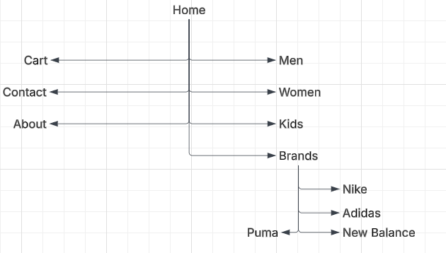

https://github.com/cse25-290/Sneaker-Galaxy

https://cse25-290.github.io/Sneaker-Galaxy/

